**GoFile – An Anonymous Cloud Storage System**

Project Name: **GoFile**

Student Name: **Guanlong Zhou**

~~Email:~~ **~~XXX@XXX.XXX~~**

**Background:**

* It is not safe to login your personal account on the public computer, because any information you typed in could be stolen by the malwares. File sharing(transfer) on public computers could be a big problem. GoFile has been developed to solve this problem.

**Introduction:**

* GoFile is an anonymous safe cloud storage system. What makes it so special is that it is anonymous, safe and free, which means you do not need to register to use it. You can safely use this cloud storage on public computers to send files to yourself, your friends and any mobile devices. Besides, it is also very convenient and safe to retrieve files on public computers. It is safe because the identity authorization mechanism is so special that you do not even need the username or password.

**Project Description:**

* *GoFile is a Dropbox-ish file storing system based in the Cloud. It is built to use under secure and insecure situations.* Here are some key points of this system:

1. No need to register or login, you will be assigned with unique access token each time
2. Access token is the key to manage your files
3. Save/Transfer your Access Token through email, sms and QR-code
4. Simply save your access token on your phone
5. Remotely authorize a public computer by your phone
6. Sharing files with friends without revealing the access token
7. Easily file transfers between computers and mobile devices
8. Automatically drop your access token when you close the browser to secure your files

* 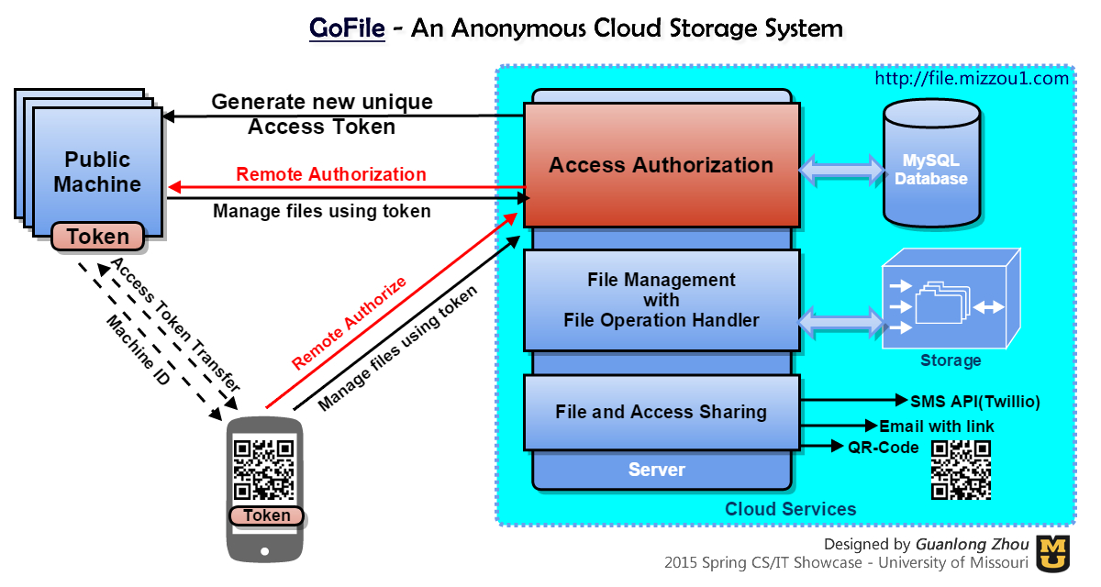**System Structure:**